**DATA MANIPULATIONS**

**Create the following tables with the given structure.**

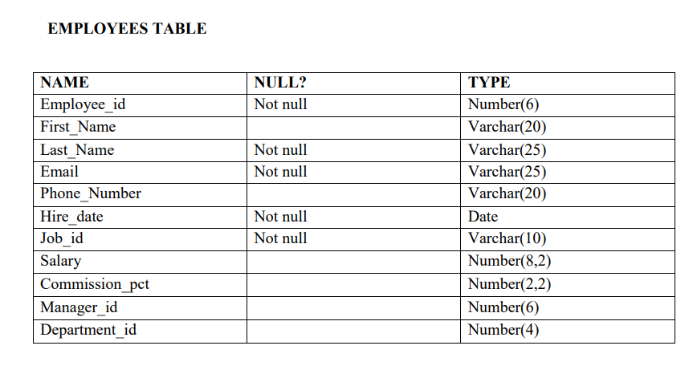

Create table employees( employee_id number(6), First_Name varchar (20) , Last_Name varchar (25), Email varchar (25), Phone_number varchar (20), hire_date date ,Job_id varchar(10),Salary number (8,2), Commission_pct number (2,2), Manager_id number (6), Department_id number(4));

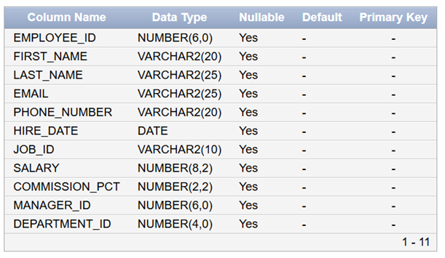

Insert into employees values(3,'Ralph','Patel','rpatel@gmail.com',9768403822,'11-12-2000',13,5000,.25,101,40);

Insert into employees values(4,'George','Austin','geaustin@gmail.com',9573268191,'09-10-2018',14,6000,.3,103,60);

Insert into employees values (1,'Ben','Chad','bchad@gmail.com',9493836325,'24-07-2022',11,4500,.15,100,70);

Insert into employees values (2,'Bety','Dancs','bdancs@gmail.com',9763467298,'19-05-2021',12,4800,.17,100,56);

Insert into employees values (5,'Audrey','Austin','audaustin@gmail.com',9684357377,'06-05-2017',15,7000,.35,104,80);

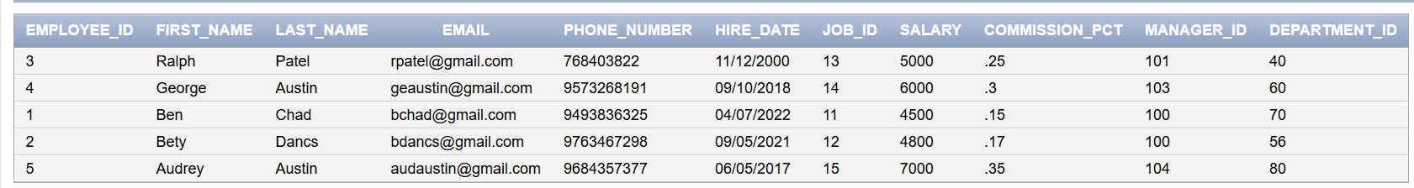

1. Find out the employee id, names, salaries of all the employees

Select employee_id, first_name, last_name,salary from employees;

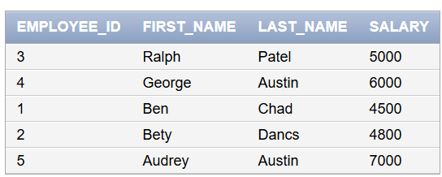

1. List out the employees who works under manager 100

select *from employees where manager_id=100;



1. Find the names of the employees who have a salary greater than or equal to 4800

Select first_name,last_name from employees where salary>=4800;

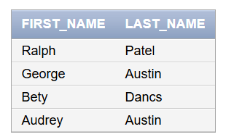

1. List out the employees whose last name is ‘AUSTIN’

Select *from employees where last_name ='Austin';



1. Find the names of the employees who works in departments 60,70 and 80

Select first_name, last_name from employees where department_id = 60 or department_id = 70 or department_id = 80;

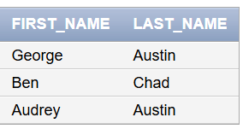

(f) Display the unique Manager_Id

Select distinct manager_id from employees;

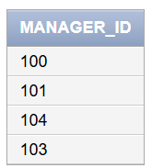

Create an Emp table with the following fields: (EmpNo, EmpName, Job,Basic, DA, HRA,PF, GrossPay, NetPay) (Calculate DA as 30% of Basic and HRA as 40% of Basic)

Create table emp1(empno number(4), empname varchar(25), job varchar(25), basic number(10),da number(10), hra number(10), pf number(10), grosspay number(10), netpay number(10));

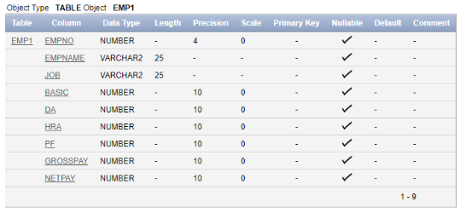

(a) Insert Five Records and calculate GrossPay and NetPay.

insert into emp1 values (1, betty,manager,7000,2100,2800,1000,10,20);

insert into emp1 values (2, annnie, secretary,5000,1500,2000,1500,20,30);

insert into emp1 values(3,ralph,technician,8000,2400,3200,2000,30,40);

insert into emp1 values(4,linda,assistant,4000,1200,1600,1200,40,50);

insert into emp1 values(5,becky,manager,9000,2700,3600,2500,50,60);

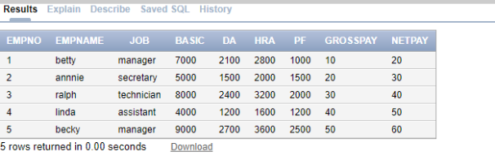

update emp1 set grosspay = basic + da + hra +pf;

set netpay = basic-pf;

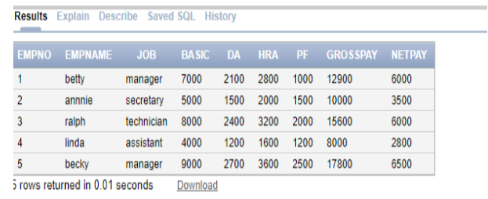

(b) Display the employees whose Basic is lowest in each department

Select * from emp1 where basic = (select min(basic) from emp1);

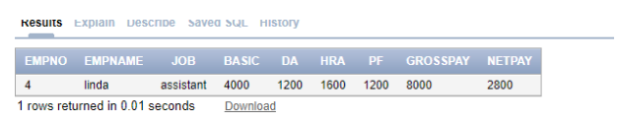

(c) If Net Pay is less than

Select * from emp1 where netpay = (select min (netpay) from emp1);

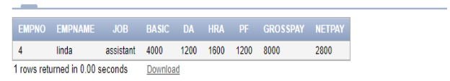

Create the DEPT table based on the DEPARTMENT following the table instance chart below. Confirm that the table is created.

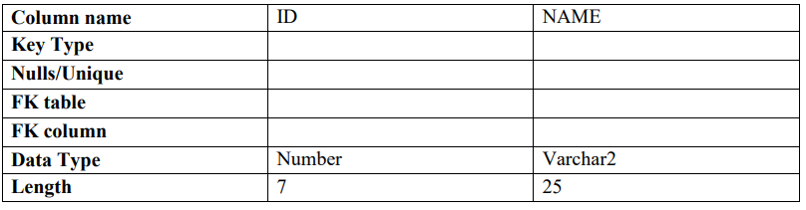

Create the EMP table based on the following instance chart. Confirm that the table is created.

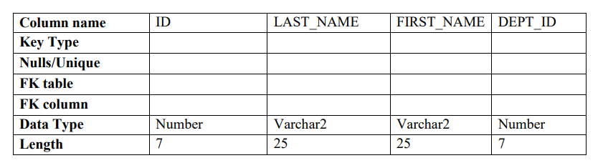

Create table emp3(id number(7) primary key not null,last_name varchar(25) not null,first_name

varchar2(25), dept_id number(7));

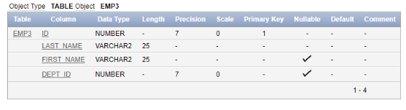

(a) Modify the EMP table to allow for longer employee last names. Confirm the modification.(Hint: Increase the size to 50).

Alter table emp3 modify last_name varchar2(50);

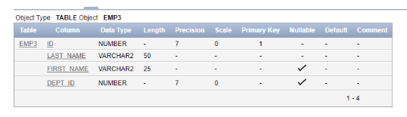

(b)Create the EMPLOYEES2 table based on the structure of EMPLOYEES table. Include Only the Employee_id, First_name, Last_name, Salary and Dept_id coloumns. Name the columns Id, First_name, Last_name, salary and Dept_id respectively.

Create table employees2(employee_id number(4),first_name varchar(25),last_name varchar(20),salary number(10),dept_id varchar(5));

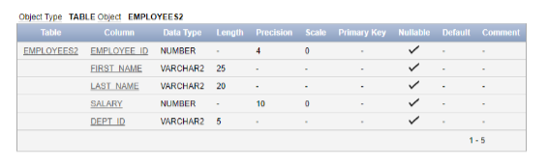

1. Drop the EMP table

drop table emp3;

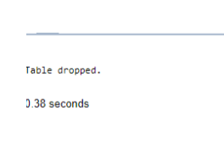

1. Rename the EMPLOYEES2 table as EMP3.

Alter table employees2 rename to emp3;

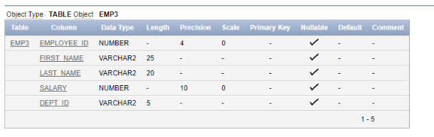

(e)Drop the First_name column from the EMP3 table and confirm it.

Alter table emp3 drop column first_name;

